**Experiment -1.2**

Creating branches with GitHub

**Student Name: Sandhya Kumari UID:22BDO10074**

**Branch: CSE(Devops) Section/Group: 22bcd-1 ‘B’**

**Semester: 4 Date of Performance:**

**Subject Name: Git and Hub Subject Code: 22CSH-293**

1. **Aim/Overview of the practical: Creating branches with GitHub**

**2. Task to be done: In this experiment, we have to create the branches, merge the branches and then delete the branches.**

**3. Steps for experiment/practical:**

1. On GitHub.com, navigate to the main page of the repository.

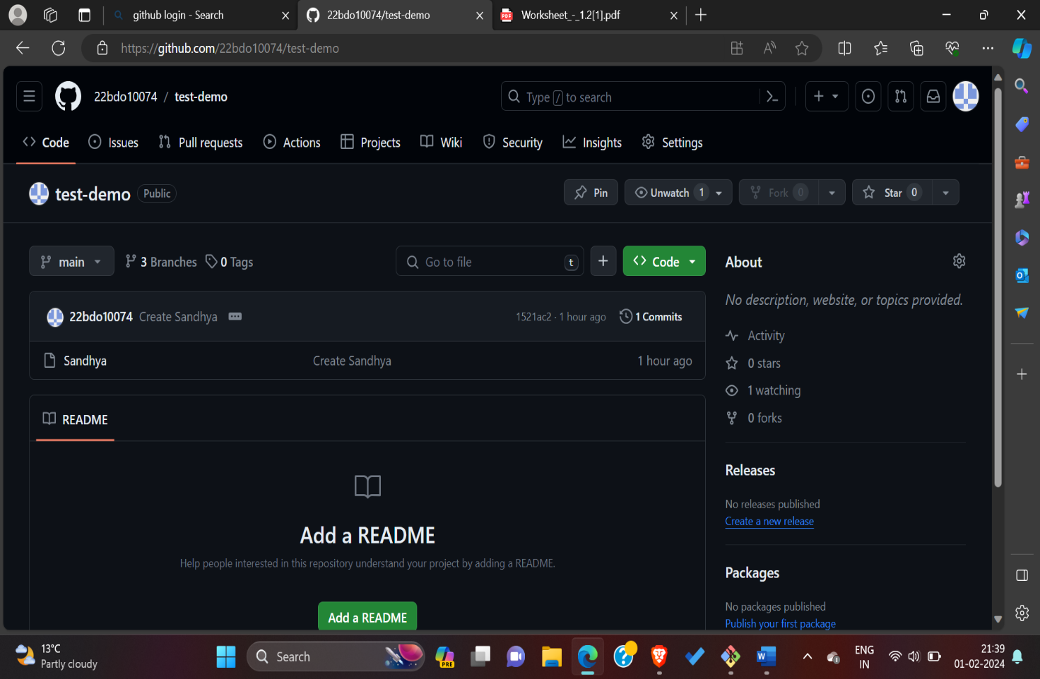

1. From the file tree view on the left, select the branch dropdown menu, then click **View all branches**. You can also find the branch dropdown menu at the top of the integrated file editor.

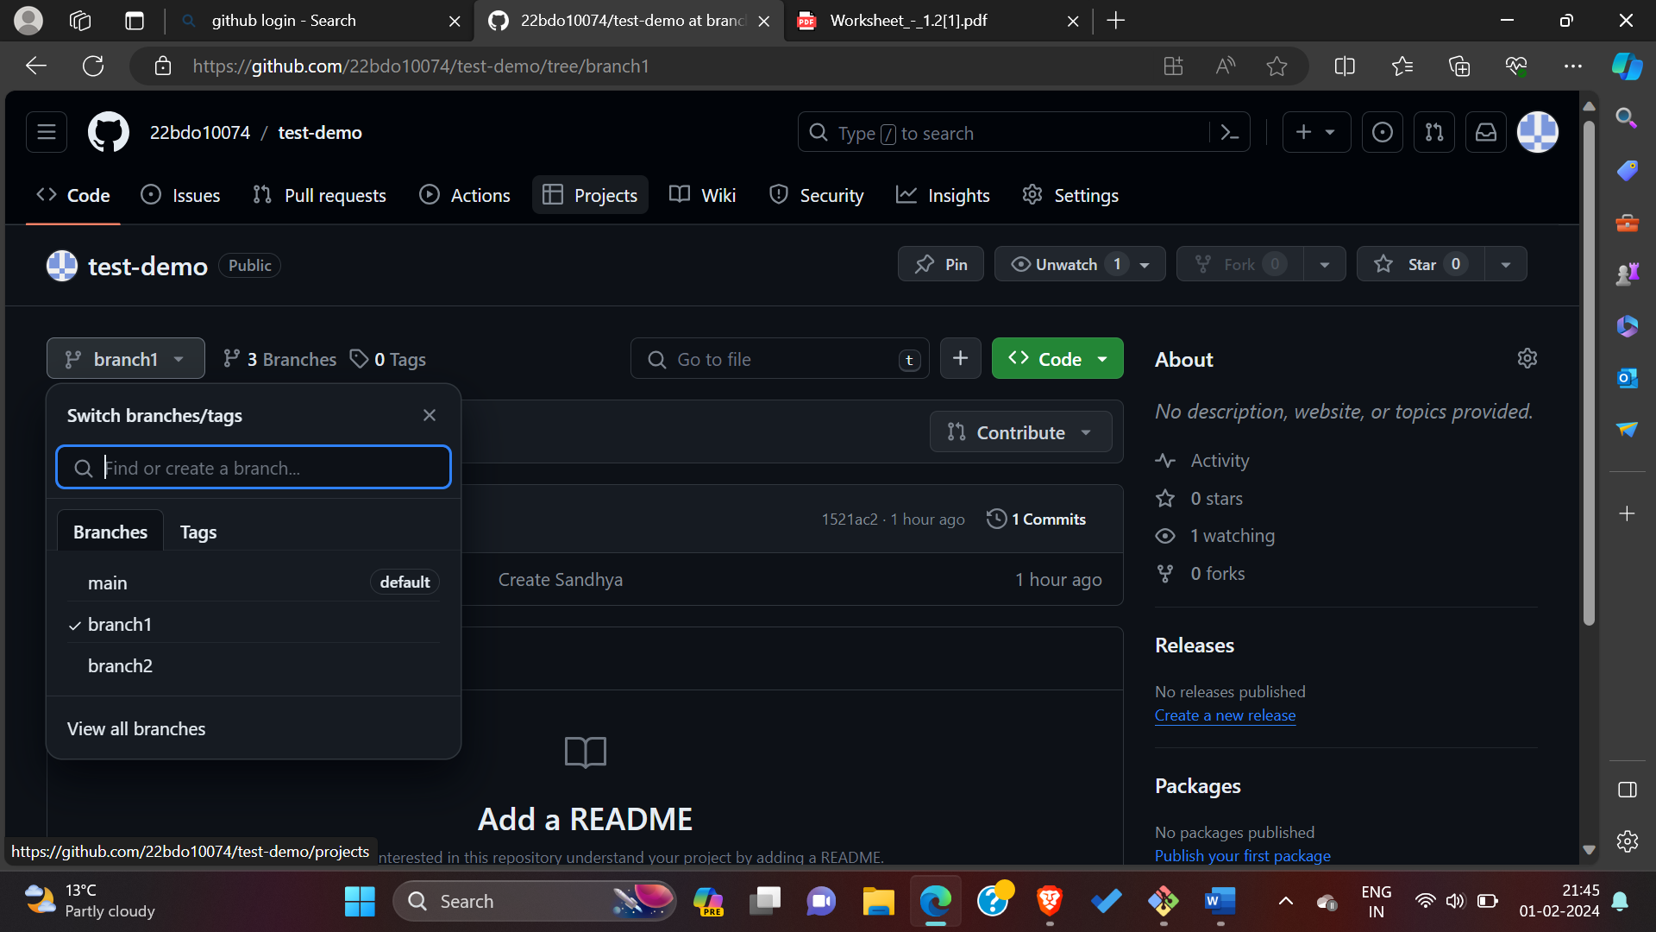

1. Click **New branch**.

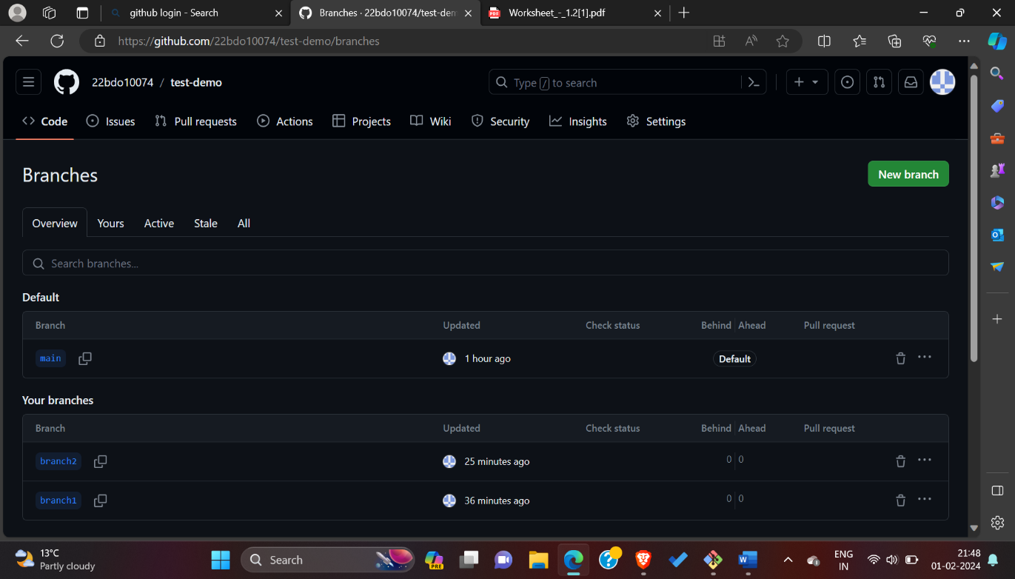

1. Under "Branch name", type a name for the branch.
2. Under "Branch source", choose a source for your branch.

* If your repository is a fork, select the repository dropdown menu and click your fork or the upstream repository.
* Select the branch dropdown menu and click a branch.

1. Click **Create branch**.

## For [Deleting a branch](https://docs.github.com/en/pull-requests/collaborating-with-pull-requests/proposing-changes-to-your-work-with-pull-requests/creating-and-deleting-branches-within-your-repository#deleting-a-branch): You can have head branches automatically deleted after pull requests are merged in your repository.

## If the branch you want to delete is associated with an open pull request, you must merge or close the pull request before deleting the branch.

## For merging and creating a pull request we must follow some steps which is to be performed in this experiment.

## Merging a pull request

## Under your repository name click pull request. Screenshot of the main page of a repository. In the horizontal navigation bar, a tab, labeled "Pull requests," is outlined in dark orange.

## In the pull request, click the pull request you would like to merge.

## 

## 3. scroll down to the bottom of the pull request. Depending on the merge option enabled for your repository, you can.

## Merge all of the commits into the base branch: by clicking merge pull request. If the merge pull request option is not shown, click the merge dropdown menu and select create a merge commit.

## Squash the commits into one commit.

## Rebase the commits individually onto the base branch.

## Screenshot of the merge options for a pull request. The arrow to expand the dropdown is outlined in dark orange.

## 4.Then select option named as create a merge commit then compare and view the pull request.

## 

## 

## 5. Next step, if you want to close the pull request, then click on the below option close the pull request.

## 6. Next to the branch that you want to delete, click delete.  If the branch is associated with at least one open pull request, deleting the branch will close the pull requests. Read the warning, then click **Delete**.

## 

## 7. Observation: Facing some problem when conflicts arises but after implementing this experiment got to know that where the problem occurs and how to resolve it.

## 

## 8.Git bash command:

$git Init

$git add README.md

$git commit -m "first commit"

$git branch -M main

$git remote add origin https://github.com/22bdo10074/demo.git

$git push -u origin main

**10. Result/Output/Writing Summary:**

You can easily create or delete branches directly on GitHub, Also I have performed this experiment successfully.

**Learning outcomes (What I have learnt):**

**1.** Understanding Git Bash Commands

**2.** Use of GitHub Repository URL

**3.** Creating a Local Copy using Git bash.

**4.** Navigating Directories.

**5.** Connecting Local and Remote Repositories

**Evaluation Grid (To be created as per the SOP and Assessment guidelines by the faculty):**

|  |  |  |  |
| --- | --- | --- | --- |
| Sr. No. | Parameters | Marks Obtained | Maximum Marks |
| 1. |  |  |  |
| 2. |  |  |  |
| 3. |  |  |  |
|  |  |  |  |